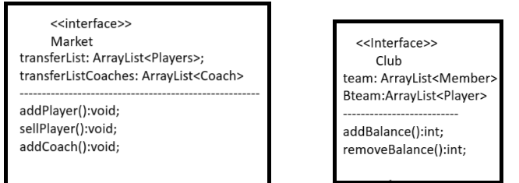



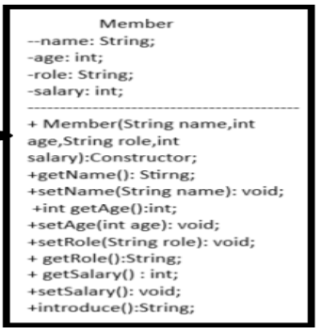

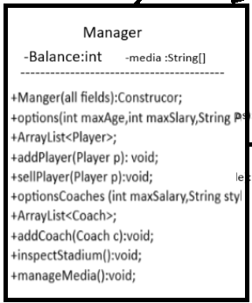 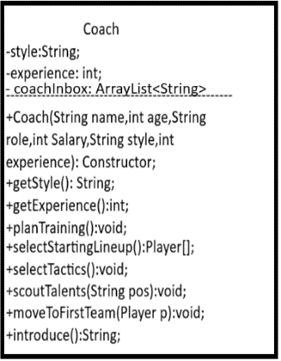



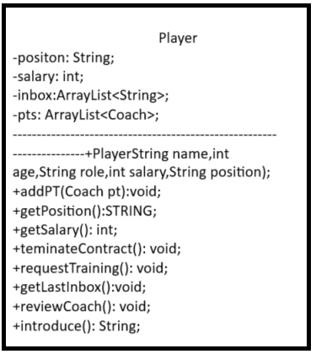



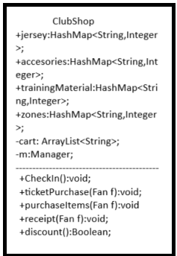 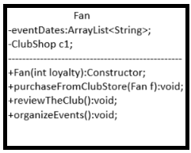



Interface Club:

Team: filed that represents the teams roster;

Bteam : represents the second team which has talents and youngsters;  
addBalnce(): add the balance of the club;

removeBalance(): remove form the club balance;

-------------------------------------------------------------------------------------------------------------------------------------------------------

Interface Market:  
transferList: List that contains all players that are available for sale;

tarferListCoaches: List that contains all coaches that are available for sale;

-------------------------------------------------------------------------------------------------------------------------------------------------------

Manager Class:

It is ingerited by upcomimg classes;

Member(all fields): constructor for the class member;

getName(): get the name of the member;

setName(): set name of the member;

getAge()://;

setAge()://;

getRole()://;

setRole()://;

getSalary()://;

setSalary()//;

aintroduce: returns a string that represents the member;

-------------------------------------------------------------------------------------------------------------------------------------------------------

Manger class extends Manager class and implements Club and Market:

Balance: a private field to keep track of the balance of the club which is the manager responsibility;

Media: an array containing string representations of the dates on which the manager has press conferences;

Manager(all fields): Constructor for Manager class;

Options(int maxAge,int maxSalary, String position): returns all available options of player available in the transfer market based on the manager preferences;

addPlayer(Player p): the manager selects a player from the transfer list and adds it to team, It also removes the salary of the new player form the teams balance;

sellPlayer(Player p): sells player and adds hi salary to the balance;

optionsCoaches(): same as options mentioned previously but for coaches;

addCoach(): removes old coach and add the new one + edits balance;

inpsectStadium(): asks the manager to improve stadium’s condition by spending money form clubs balance;

manageMedia(): Display the upcoming press conferences for the manager and asks the manager if he wants to remove any press conference;

------------------------------------------------------------------------------------------------------------------------------------------------------

Coach class extends member:

style: represents coach’s style;

Experience: represents the number of years the coach has been working;

Coach(all fields):Constructor for Coach class;

getStyle(): get style of coach;

getExperience(): get experience years;

planTraining(): asks the coach to enter the date for his next training session and adds the date to playes inbox;

selectStartingLineup(): iterates through payers in the team and asks the coach to select three of the players as the starting lineup then displays the final starting team;

selectTactics(): asks the coach to enter his attacking + defending tactics and formation then displays the tactics for the upcoming match;

scoutTalents(String pos): based on the entered position talents from the B team are displayed to coach;

moveToFisrtTeam(Player p): moves the player p to first tea from B team;

introduce(): overrides to display coach details

Coach Player extends Member:

Position: represents player position in field;

Salary: represents player salary;

Inbox: list of player inbox;

Pts: list of all personal trainer the player has;

Player(all fields): Constructor;

addPT: adds a personal trainer to the list;

getPositon():returns position;

terminateContract():terminates player contract and removes from team;

requestTraining(): the player requests a training session from his pt and the pt is messaged;

getLastInbox(): prints last inbox the player has;

reviewCoach():where the player can mail the coach about any concerns;

introduce() :overrides to introduce the player;

-------------------------------------------------------------------------------------------------------------------------------------------------------ClubShop:

checkIn(): method to introduce shop users and check their presence;

purchaseItems(): the user chooses if he wants jerseys, accessories, or training materials, then is shown the map of items and his prices, then what he chooses is added to the cart;

ticketPurchase():the user can purchase ticket for different zones and prices, also added to cart;

receipt():shows the user his receipt of all items and their prices + the total sum;

discount(): Boolean method that check if the loyalty field for a fan exceeds or is equal to 10, if so it gives a discount of 20% on all the purchases;

Fan:

purchaseFromClubShop(): executes all methods found in ClubShop class(the user has a shopping experience);

reviewClub(): the fan can send feedback to club members;

organizeEvents(): the fans can set event dates which are added to the eventDates list;